MLSP Assignment 5
report for Question 2:

part a: CNN without maxpool
Loss plot: for 20 epochs
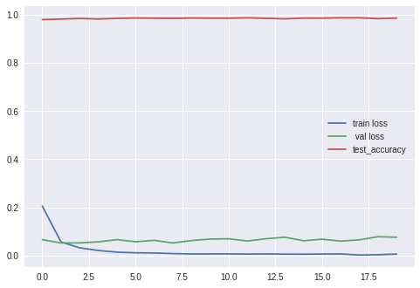
Test Accuracy for this model is:
98.17%

Validation loss is almost constant and increasing. Training loss is decreasing. It shows overfitting after 10 epochs. But why the validation loss never decreased. We can see test accuracy is almost constant. That means loss is changing, but accuarcy is not changing. Number of example sbeing correctly classified is being almost same, but their confidense is decreasing.

2_b: effect of momentum,NAG:
by Using momentum, convergence became faster. Loss value decreased faster as compared to without momentum. Nestorov momentum was a bit more better, as compared to simple momentum.

part c: CNN with maxpool:
Loss Plot:
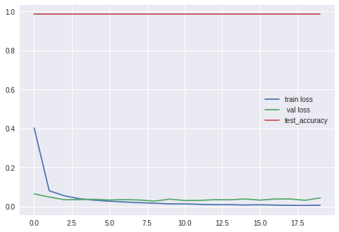
Test Accuracy for this model = 99.26%

CNN models are requiring a lo more time for computation as compared to DNN. But these are giving better accuracy, since cnn are good to capture spatial local information in images.
Dont know why the test accuracy or validation accuracy in the first epoch is above 90%.

